Background
In 2017, the Utah Medical Education Council (UMEC) along with the Utah Are Health Education Centers (AHEC) began to look at how to improve estimating need for the healthcare workforce in the state of Utah in a primary care, team-based care delivery setting. This effort came together out of requests from state legislators and other policy makers to receive more detailed information about healthcare workforce needs when making decisions about how to allocate government funding for these programs. Discussions about sufficient supply of workforce in healthcare have long centered around the supply of a single profession to 100,000 population ratio. Federal health professional shortage designations as well as many other programs for distributing government resources are based on these ratios. There are two inherent assumptions built in to this type of comparison. The first is that for a given area, current supply equals demand. Projections of future growth are then pegged to maintaining at minimum, the current ratio of each profession to the population. The second is that if the ratio for a given geographic area is lower than another geographical area or the national average then there is a shortage of that profession in that area. While calculation of a healthcare profession to 100,000 population is easy to calculate and compare across geographic locations, this approach provides no consideration for how healthy a given population is, or how efficient the healthcare delivery system is in determining whether or not supply is sufficient to meet population need. Especially in context of team-based care delivery.

The initial work for the UMEC/AHEC team resulted in identifying a way to go beyond the metric of provider to population ratios by calculating an estimate of FTEs needed to deliver health care across the state based on the needs of the population in comparison to the number of FTEs in the current healthcare workforce supply.
The team sought to answer four specific questions:
- What are the prevalence of Chronic Diseases and incidence of Acute Conditions in the population?
- What evidence-based services for care of common Chronic and Acute Conditions and for Prevention?
- How much time is needed to deliver each of these services?
- Which medical provider should deliver each service to optimize cost, quality, and suitability to license/profession in a team context.

The work of answering these questions aligns nicely with the needs based analytical framework developed by Stephen Birch et al. This framework consists of two independent components, provider supply and provider requirements.
Provider supply ﻿measures the number of providers who are (or will be) available to deliver healthcare services to the population. It is the outcome of two determinants in a stock and flow relationship. The stock is represented by the number of individuals licensed in each healthcare profession by age and sex who are available to provide services. The flow is represented by the quantity of input of activities generated from the stock, (eg, time spent in the production of services).
﻿The flow of activities depends on the proportion of the current stock that is active in the provision of healthcare (ie, the participation rate) and the level of activity or hours spent in delivering services by those participating in the provision of healthcare (ie, the activity rate).
Provider requirements measures the number of providers required to ensure sufficient “flow” of healthcare services to meet the needs of the population. Birch points out that ﻿traditional approaches to estimating the required number of FTE providers (N) have largely been based on an implicit analytical framework of just two elements—the population demography multiplied by the current level of providers in the population, represented in the equation:
N = (providers/population) × (population size).
Because service requirements and number of required providers vary according to age and gender mix of the population, requirements must be calculated for each age/gender group and then summed to arrive at total providers required (N).
Because need for care in the population represents the most appropriate approach to determining provider requirements, Birch explains that in order to introduce need for care into the calculation, that the provider/population variable must be further disaggregated. The equation becomes providers per services multiplied by services needed to address a given condition, multiplied by needs in the population, multiplied by the population size. ﻿
N = (provider/services) × (services/need) ×(needs/population) × (population size)
Each expression in the equation represents a separate determinant of provider requirements (N). These determinants are as follows:
Demography: the size of the population being served.
Epidemiology: the distribution of health and illness as well as risk factors for future illness in the population (needs/population).
Level of service: the amount and type of health care services planned to be provided for different levels of health, illness or risk of illness (services/need).
Productivity: the quantity of Full Time Equivalent (FTE) providers required to deliver a given level and mix of services (provider/services).

Utah sources for data to describe these determinants were identified by the UMEC/AHEC team.
Demography
These estimates are produced through projections at the state level based off of the decennial federal census. Population numbers are broken down by age, gender and geography. These population projections are broadly trusted and widely used by every industry as the basis for their own planning and projections. They are used to determine funding for transportation, infrastructure, city planning etc. In Utah these projections are produced by the Kem C. Gardiner Policy Institute at the University of Utah Eccles School of Business.
Epidemiology
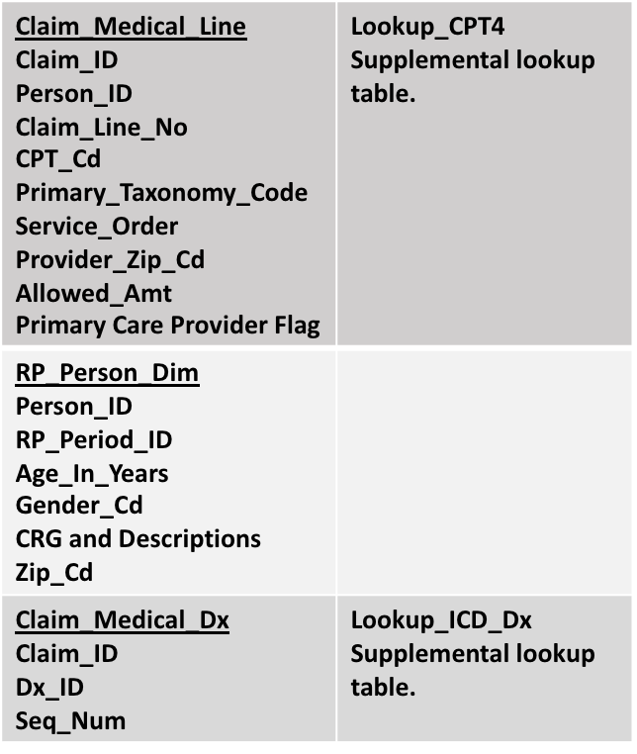
Because different people have more likelihood to face specific health issues through their lives, illness must be described in categories that match population categories (age, gender and geography). Initial exploratory work with the state’s All Payers Claim Database (APCD) was completed by UMEC and AHEC staff in cooperation with the APCD administrators from the Utah Department of Health to determine possible usefulness of APCD data as a source for the model. The APCD is a large state-maintained database that includes medical claims, pharmacy claims, dental claims, and eligibility and provider files collected from private and public payers. APCD data are reported directly by insurers to States, usually as part of a State mandate. As of the most current estimate, Utah’s APCD covers an estimated 63- 75% of the state’s entire population. This includes Medicare, Medicaid, CHIP, commercial, etc. The APCD contains between 72-91% of Utah’s commercial/employer coverage. The population coverage of the APCD is constantly increasing. Claims in the data have all been processed and adjudicated by their respective insurance company. Data processing vendors who clean the received insurance data and aggregate it into the form required by APCD also use a suite of hundreds of edit checks on the data. Files that do not pass the edit checks are not accepted into the database. With a documented approach to how to use this data, the usefulness of the APCD will increase with each update to the data. Work has already been done to establish access to this data by the UMEC to perform the required analysis. Data accessed by the UMEC from the APCD is strictly controlled and defined by a specific set of variables that the UMEC has been granted access to. The requested data is stored in a SQL database for analysis. Code used to query the data will be saved to allow for exact replication of the query.
Utah APCD Variables for Analysis
Preventive service needs can easily be calculated by drawing on existent recommendations from the healthcare literature and professional recommendations for what services should be delivered and how often, by age and gender and applying those recommendations to the total population. Initial work has already been done by the UMEC/AHEC in compiling evidence-based care guidelines published by a variety of healthcare entities and translating these into a list of preventive services that should be delivered.
The most easily accessible and widely available data source for tracking the prevalence of chronic conditions across the country is through the CDC’s Behavioral Risk Factor Surveillance System (BRFSS). This program tracks chronic health conditions prevalence in every state in the nation through a series of sample surveys done by telephone. It is the largest continuously conducted health survey system in the world. BRFSS provides estimates as a percentage of the population by the necessary categories to match the population data. This allows BRFSS to be easily incorporated as a source for Chronic disease prevalence in the population.

Levels of Service
Encounter and service details are driven by population epidemiology. The type of encounter (chronic, acute or preventive service delivery) and the severity classification of a given patient in the population determines which services should be provided. Patients who are healthy may only require preventive care services. The services delivered to patients with acute needs will vary by severity. Services delivered to patients with chronic conditions will vary by comorbidity grouping. Within any encounter there are standard office visit services that are delivered as well as situation-specific services. Some of these services only occur once or twice a year and not necessarily with every encounter. These service details are established to avoid double counting of specific services when using them in model calculations.

Productivity
Determining the FTE number of providers required to deliver the services to the population requires setting the amount of time a given service takes to deliver and which professions are suitable to deliver each service. These values are currently provided by expert opinion. There is no known publicly available data source for how much time a service takes or which provider, in context of a care delivery team should provide a given service in terms of cost and quality. The establishment of time values and suitability designations for different providers within a care team that are widely agreed upon and accepted as model inputs will be within the purview of the work of Aim 2 of this grant.
Provider Supply
This data is sourced from healthcare licensing and workforce supply survey data tracked by the UMEC in the state of Utah regularly over the last 20 years. It contains descriptive data by profession on the age, gender, geographic location, specialty and work setting of the healthcare workforce in Utah. It also contains the necessary information about number of available hours working in direct patient care to determine the flow of the provider supply determinant from the analytical framework.
The needs-based analytical framework is dynamic. Changes in one determinant have potential effects on other determinants. For example, changes in the population to which a service is delivered or changes in the services to be delivered for a given need may change the required number of providers. The needs- based analytical framework describes how to estimate need for one type of provider delivering a specific list of services. Making an estimate of which types of providers are needed to deliver team-based care requires an optimization of providers in the system by which provider is best to deliver care in terms of cost and quality.

IBM Engagement
For their 2018 application cycle the IBM Health Corps announced intentions to accept proposals to tackle heath disparities in the areas of cancer (early detection & access to care) and health workforce strengthening and support. With the work that had been done in conceptualizing how to go about calculating healthcare needs of the population, the UMEC/AHEC group was primed to be an ideal candidate to apply for support from IBM. The project application pitched to IBM was to take the initial work of UMEC/ AHEC, including some initial modeling done in excel based on the need-based analytical framework and create a tool for estimating primary care need in the population and the required team of professionals to deliver the services needed. The work that was done by IBM over a three week intensive engagement with the UMEC/AHEC team is valued at $500,000.

The IBM engagement built off of the initial work done by the UMEC/AHEC. It created a functional modeling tool prototype. This tool is intentionally designed to provide a source agnostic modeling framework to feed data into. The prototype takes in 12 different data tables to be drawn on in the modeling process. The prototype has initially been provided with mimic data in order to assure that the functionality of the tool works as desired. To achieve the most accurate results from the optimization model, each piece of information requires a reliable, consistent data source. Because no data source is perfect, it is important to understand the limitations of each, and the potential impact of those limitations on the final answer provided by the prototype.
The model can use whatever data is provided to it as long as the data source can be prepared to fit within the parameters required of the model and be considered an acceptable representation of the factors required in the modeling. Data source types for the model can be divided into 5 subject areas:
Population- Estimated counts categorized by age, gender, geography and social determinant of health score (aligns with need-based analytical framework requirements for demography data). The prototype is currently using census data to provide population counts. The tool will use Utah projections from census data produced locally for population estimates by year.
Healthcare needs- prevalence in population categorized by chronic condition, acute incident, and preventive services (aligns with need-based analytical framework requirements for epidemiology data). The prototype currently uses data from BRFSS to provide prevalence of chronic disease. Prevalence for acute conditions was calculated using IBM MarketScan Commercial Claims and Eligibility database for 2016 for the US. However, it is anticipated that the Utah APCD will be a more reliable source of information for the Utah population as it includes multiple payers and reflects the more localized Utah population. Preventive prevalence is determined by the population size in different ages and genders.

Encounter details- categorized by encounter type, category and services delivered (aligns with need-based analytical framework requirements for level of service data). A list of services that should be provided for a given condition have been generated from the existent literature. Analysis of the Utah APCD will also provide a list of services that were delivered based on a given diagnosis. Comparison of services provided to services recommended in the literature can be analyzed for differences.
Service details- categorized by service type, assigned time values and professional suitability to task (aligns with need-based analytical framework requirements for productivity data). Time values and profession suitability are currently provided by expert opinion. There is not a publicly available data source for this type of data. Tie values and scores will be assigned for each service in the list of services from standard of care literature and those generated from services provided by encounter details from the APCD data.
Provider supply- categorized by age, gender, geography and wage (aligns with need-based analytical framework requirements for provider supply data). Supply data is provided from the most recent updates to the UMEC supply datasets for each profession in the model.
The programming work done by IBM advances the need-based analytical framework by providing a way to optimize the estimate through the use of linear and quadratic programming equations designed to find the optimal number of FTEs required in terms of constraints set on what services are required to be delivered in the population, which providers are suited to the task of delivering the service, cost of different providers and the number of providers currently available in a given geography and year.
Outputs of the model can be filtered by population age, gender and geographic location. Outputs can also be projected forward to any given year for which there are population statistics. Utah’s current population projections go out to the year 2060.
Modeling Outputs
The analytical modeling in Python uses different optimization algorithms from Python libraries in PuLP and CVOPTX depending on the desired analysis goal. Each of the modeling options returns output in the form of time allocation (i.e. for each service, which provider types spend how many minutes), deal team composition, total wage, total suitability, and detail F2F time allocation for each service by provider type depending on the constraint options selected and the geographic filter. The output also returns additional corresponding supply statistics. With a general use case of a given population with described patient needs in terms of chronic, acute and preventive services to be delivered, how many and what types of providers are needed to provide the care. The three output options are as follows:

Ideal provider staffing
This option finds an optimal provider team composition (i.e., types and number of providers) based on wage and suitability score. Wage is the mean/median wage of each provider type. The value of the Wage input by provider type could also be replaced with any other cost value by provider type such as provider reimbursement for a given service or cost of care for a given service. ‘Suitability’ is a placeholder variable for users to consider allocation of time to each provider type by a secondary factor besides wage. Examples of inputs to the suitability variable would be a score indicating whether a service is at the top/bottom of license or a quality measure for a specific service by a given profession. This score is a necessary component of making a calculation of which provider is best assigned to deliver a service in a situation where multiple providers may be legally or technically able to deliver a service, however it does not make sound financial or patient satisfaction sense to assign a service to a certain type of provider (ex: although a Physician can perform simple tasks like taking a blood pressure, this is a task more suitably assigned to an MA or perhaps an RN if an MA isn’t available). If there is no consensus on where the suitability score should be set for a given group of providers that might be considered equally suitable to provide a specific service, then the suitability score can be set to be equal among the group of providers able to deliver the service. Total time required to deliver this service will then be allocated to each provider type equally. Suitability can be any number between [0-1].

The scale of suitability can also be limited in order to avoid selecting the top or the bottom of the scale by a user providing a suitability target score (ex: setting suitability target at .8, would force the model never to select a provider with a score of 1 to provide a service. This can be used to model avoiding burnout by a given profession from delivery of only one type of service, such as only assigning physicians to highly complex care all of the time. The optimization calculation of this output is based on linear programing (python Pulp library).

A users can choose from three sub-options for the modeling output as well.
all_combination tries different weight combinations (0 to 1, with 0.1 interval) between wage and suitability. Ideal provider staffing considers documentation and coordination time (overhead time) for delivery of services. This is not reflected in the calculation of ideal time allocation by service. Overhead time is calculated in addition to service time and is output in the comparison of total FTEs by provider needed to deliver services, compared to total FTEs supplied by profession.
wage_max allows users to set a maximum available wage budget. It then returns ideal provider staffing constrained by the set wage maximum.
wage_weight allows the user to provide a wage weight (any number between 0 and 1) and tries wage and suitability weight combinations like in the all_combination suboption.

Ideal provider staffing constrained by current providers’ composition

This option finds an optimal provider team composition in addition to current supply (ex: if there is already two physicians and 4 RNs and 5 Mas, how many more providers are needed to achieve the optimal allocation to meet the population needs?).
This ﻿option finds optimal time allocation based on weight between wage and suitability, and currently available provider constrains. It first subtracts overhead time from available supply time, then for each provider type where F2F time is more than population need, the calculation is performed. If a specific provider type has higher current supply than population need then that provider type will not be included in the calculation. Otherwise, it uses the same three sup-options that are available for ideal provider staffing. The optimization calculation of this output is based on linear programing (python Pulp library) and use current supply as an additional constraint.

Ideal service/task allocation

This option calculates the optimal service allocation constrained by the current provider workforce composition (ex: given a workforce of 2 physicians, 1 RN and an MA, which is not sufficient to meet the needs of the population, how can service be allocated across providers to minimize over-allocation to a certain provider type?).
The option finds optimal time allocation to minimize the variance between current supply and population need. First it calculates overhead time. If the overhead time is higher than current supply, it does not consider overhead time. Otherwise, it subtracts overhead time from the current supply time and finds the time allocation to minimize the variance between supply and need. It does not consider wage or suitability. This allocation is purely based on F2F time in order to avoid over-allocation. If wage or suitability are important, the output can also find a weighted variance. This optimization calculation uses a quadratic programing equation (python CVXOPT library). The algorithm constructs a matrix from variables P, q, G, h, A and b, and solves following equation:
Post IBM Engagement
At the end of their three week intensive engagement, IBM provided a large amount of documentation on the work they had done along with notes and directions on what work could not be completed within the timeframe. A github page was set up to keep track of the code work that was done for the project. This way the project can continue to be developed over time. During their engagement, IBM went through a process of design workshops to describe the “ecosystem” they would be working in as well as the “as-is” and desired state of the healthcare workforce in the state of Utah. The IBM designers provided application mapping and user interface flow documents as well as wireframes and descriptions of work to be done to complete a user interface for the analytical model so that in the future, the model will be able to be accessed and used through a web-based interface.
Additional project funding to complete the build of the user interface was provided by the Utah state legislature in the amount of $300,000 in the 2019 legislative session. The UMEC/ AHEC team has contracted with a user interface designer, based on skill and knowledge requirements from IBM. The team spent the remainder of the 2019 calendar year building the designed user interface functionality in order to provide a working tool for doing the work of the aims described in this grant.
User Interface Features
The user interface was designed and partially built during the IBM engagement in October of 2018. Work was continued after the engagement period to complete functionality of all designed features of the interface.
The interface provides a map of the state of Utah that shows supply/ optimal need by profession. The interface can be filtered by the individual counties, and the 7 multi-county districts (MCDs). It is anticipated that in the future, more granularity may be desired, such as analysis by the 99 Utah Small Health Statistics Areas (developed by the Utah Department of Health) or even by individual zip code. The interface is able to allow changing this data as sources with identified common geographic data comes available.
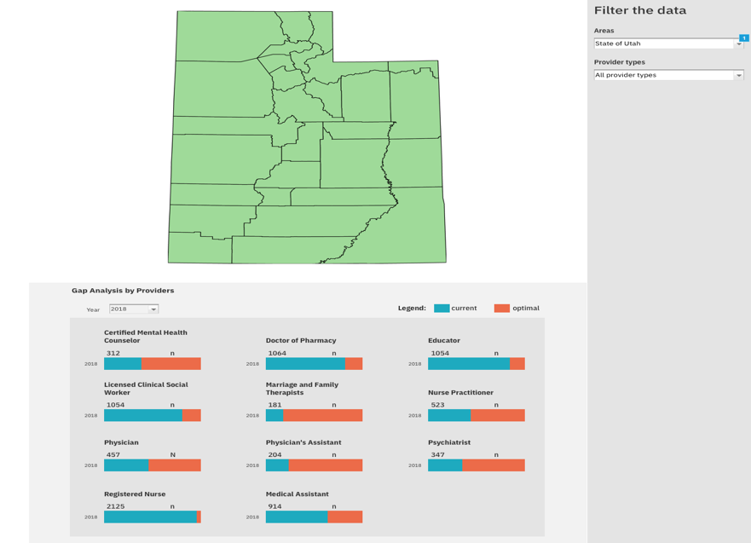
The interface provides current vs optimal workforce counts by number with the option to directly change supply numbers in the interface and have the model re-run with the replacement numbers.
Figure 1: Primary Care Workforce Estimate User Interface: Utah Map by County
When modeling inputs are changed through the user interface, the user has the option to register a profile and save their changed version of the model for comparison with others or for their own future analysis.
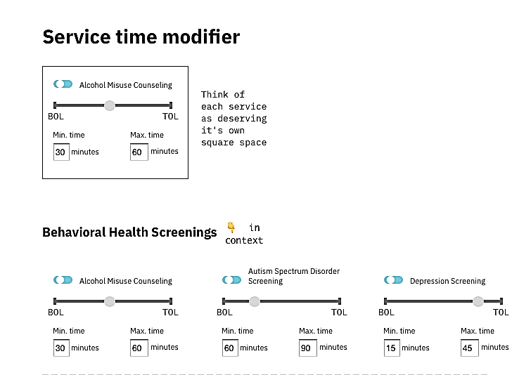
High and low time values, wage budget and suitability scores for each service included in the model can also be modified to user preference. With these changes, the model can re-run outputs as desired. Which providers are included as an option for who provides each service is also able to be changed through the user interface.
Figure 2: User Interface Service Time and Suitability Modifiers
Administrative roles in the user interface allow for adding and
removing user profiles along with adding and removing datasets.
Figure 3: Administrative Interface

Administrators and users can access and retrieve their data and user settings. As users interact with the model and save their version, an administrator can go in and compare different modeling scenarios for insight into how the tool is being used in different settings.

IBM Health Corps is a global pro bono program focused on tackling health disparities. Akin to an incubator, they provide the environment, experts, and services needed to nurture new ideas in public and population health that use technology to expand access to health services and improve health systems and population outcomes. Deploying a team of 5-6 IBM experts to work on-site with a partner organization for 3 weeks, their aim is to empower and equip health organizations to take forward a mission-driven strategic priority.
https://pythonhosted.org/PuLP/
https://cvxopt.org/
https://github.com/UMEC/healthcare-workforce
Complete design artifact documentation is available upon request

